Contributions of Scientists to Medicine

By: Jonathan Quang   
Stuyasent ID:4511

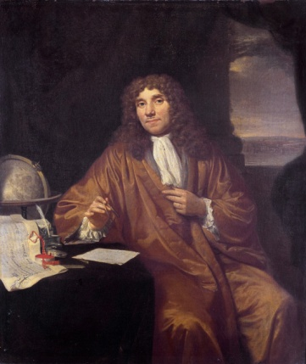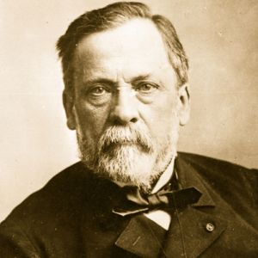

Based on the book Microbe Hunters by paul de kruif

Jonathan Quang Stuyvasent ID: 4511

Throughout history, man has always strived to better understand nature. It was not until the events detailed in *Microbe Hunters* by Paul De Kruif that humanity began to understand microbes and developed further understanding of biology. Of the many scientists who contributed to the understanding of biology, three of them stood out because of their contributions to medicine. Robert Koch stood out because he showed that disease must come from somewhere and showed ways of isolating bacteria from others. Louis Pasteur stood out because of his vaccines and cure for rabies. Paul Ehrlich stood out because he was one of the first to engineer non-lethal chemicals to combat diseases. Thus, these contributions to the knowledge of humanity have affected the development of a number of medical disciplines.

Firstly, Robert Koch's research with microbes lead to the conclusion that disease must come from somewhere and lead to a way of isolating microbes. He has proved that anthrax was caused by a certain species of microbes. When drawing a comparison between healthy animals and those with anthrax, he noted "'Those threads are rods are never found in the blood of any healthy animal," Koch pondered,"-this is all very well, but it doesn't tell me whether they are bacilli, whether they are alive...it doesn't show me that they grow, breed, multiply..."' (Kruif 106). Koch noticed this, but instead of rushing to conclusions, he researched further. Koch needed to isolate this microbe, so he heated a liquid until it was sterile over a glass slide, then put the diseased sample in the liquid. Then he glued it shut by placing a concave glass slide over the other slide. By injecting the newly grown microbes into mice, he proved it was the cause of anthrax. However, he was now presented with a new problem. The microbes that caused anthrax died in two days, but infected fields stay infected for months. In the text, it states, " He (Koch) had kept a hanging drop (isolated microbe slides)... at the temperature of a mouse's body for twenty-four hours...he saw that ... the shiny little beads were inside the thread , the bacilli that made up threads have turned into these beads... the beads must be the spores of the microbe - the tough form of them..." (Kruif 114 - 115). When Koch later researched the cause of Tuberculosis, he saw that bacteria would grow naturally in isolated colonies on solid food and created broths specifically for growing isolated colonies. Eventually Koch began to research Cholera. The common theory at his time was that it arose from bad attitude or was caused by several species of microbes. However, Kruif writes "Koch found his comma bacillus in the dead bodies of every one of the forty carcasses... but he never found this germ in any of the hundreds of healthy Hinds...nor in any animal...He dredged this comma microbe up out of the stinking water... "Cholera never rises spontaneously," he told his audience, "no healthy man can ever be attacked by cholera unless he swallows the comma microbe, and this germ can only develop from its like..." (Kruif 137). Koch had proved that these diseases were caused by microbes and only arose from microbes. The isolation of microbes and proving that microbes were the cause of disease led to improvements in medicine. Essentially, Koch had contributed to medicine because he laid the groundwork for how to identify diseases and how to avoid catching some diseases.

Secondly, Louis Pasteur’s discovery of vaccines and a cure for rabies contributed to the understanding and development of medicine. While vaccines or vaccine equivalents have been used before, Pasteur did make one closest to modern day vaccines. He became interested in vaccines once he realized that a cow that has recovered from anthrax cannot suffer from anthrax again. This theory was then applied with chickens. Pasteur came to the realization that “‘All we have to do is let our virulent microbes grow old in their bottles...instead of planting them into new ones everyday...When the microbes age, they get tame… they give the chicken disease...but only a little of it… and when she gets better she can stand all the vicious virulent microbes in the world...We’ll apply this to...all virulent diseases,”’ (Kruif 149). With this realization, Pasteur would invent a vaccine to save animals from cholera and anthrax. However, curing rabies with vaccines required something more than a single vaccine. While testing a vaccine for rabies was successful with dogs by injecting one rabies vaccine a day for fourteen days with the strength gradually increasing, Pasteur wondered if he should take a risk with human testing. That risk was forced to be taken when nine-year old Joseph was brought to Pasteur. In the text it states, “...that night of July 6, 1885, they made the first injection of the weakened microbes...into a human being. Then, day after day, the boy Mesiter went without a hitch through his fourteen injections...And the boy went home… and had never a sign of the dreadful disease,” (Kruif 174). With this, the knowledge and ability to use vaccines to actually cure rabies became available to mankind. Pasteur understood how the immune system worked, and now the world knew how to use that knowledge. Hence, Louis Pasteur’s discovery of vaccines and a cure for rabies contributed to the understanding and development of medicine.

Thirdly, Paul Ehrlich’s experimentation with chemicals to treat diseases contributed to the understanding and development of medicine. Paul Ehrlich constantly experimented with chemicals to kill trypanosomes of the mal de Caderas without killing the mice infected with it. The author writes that Ehrlich and his assistant tested chemical 606 (Dioxy-diamino-arsenobenzol-dihydro-chloride) on spirochetes in rabbits because spirochetes were thought to be cousins of trypanosomes, and the disease caused by those microbes was also cured. That disease was syphilis. Kruif states, “So this compound six hundred and six, saving its thousands from death, from insanity, from the ostracism worse than death that came to those sufferers whose bodies the pale spirochete gnawed until they were things for loathing...Let us remember him (Ehrlich), trail-breaker who turned a corner for microbe hunters and started them looking for magic bullets,” (Kruif 348-349). With Ehrlich’s efforts, he not only created a cure of syphilis, but also inspiration for others to look for a magic bullet, a chemical that would cure all diseases. He set an example for endlessly testing and modifying chemicals to kill or tame microbes. Therefore, Paul Ehrlich’s experimentation with chemicals to treat diseases contributed to the understanding and development of medicine.

To conclude, Robert Koch, Louis Pasteur, and Paul Ehrlich stood out because of their contributions to medicine. In medicine, a discovery has been made in June of 2014 . Scientists have shown the bacteria can evolve timers to avoid antibiotic treatments. When antibiotics are introduced to colonies of bacteria at regular intervals of time, they will evolve dormant stages that match the intervals of time. For example, when the antibiotic is introduced every eight hours, the bacteria will revert to a dormant stage every eight hours. This suggests that antibiotics should be administered in irregular intervals for maximum effectiveness. There always seems to be something new about microbes we have yet to discover.

Bibliography

1. Kruif, P.(1996). *Microbe Hunters*. Orlando, Florida: Hardcourt, Inc.

2. The Hebrew University of Jerusalem. (2014, June 30). A first: Scientists show bacteria can evolve biological timer to survive antibiotics. ScienceDaily. Retrieved August 1, 2014 from www.sciencedaily.com/releases/2014/06/140630103140.htm